# **Task Answers**

**Objective Answers**

**Q1) What is the total no. of tables present in the data?**

Ans1)There is two tables in Data

1. Raw Data
2. Country Description

**Q2) What is the total no. of attributes present in the data?**

Ans2) There are 20 attributes in data following

1. RestaurantID
2. RestaurantName
3. CountryCode
4. City
5. Address
6. Locality
7. LocalityVerbose
8. Longitude
9. Latitude
10. Cuisines
11. Currency
12. Has_Table_booking
13. Has_Online_delivery
14. Is_delivering_now
15. Switch_to_order_menu
16. Price_range
17. Votes
18. Average_Cost_for_two
19. Rating
20. Datekey_Opening

**Q3)How many categorical columns are there in the data? [Search about categorical and continuous data, and try to answer this question]**

Ans3)

The categorical data consists of categorical variables which represent the characteristics such as a person’s gender, hometown etc.

There are 14categorical columns in the data, all are mentioned below.

RestaurantName

CountryCode

City

Address

Locality

LocalityVerbose

Longitude

Latitude

Cuisines

Has_Table_booking

Has_Online_delivery

Is_delivering_now

Switch_to_order_menu

Average_Cost_for_two

Datekey_Openin

Q4) The data consists of some inconsistent and missing values so ensure that the data used for further analysis is cleaned.

Ans4)

For cleaning the whole data, We first selected the whole Raw Data table and then by Data Cleanup function, we will remove whitespaces present in some cells and then, we will check for duplicate data, here all rows are unique. After checking we found that some city names were not correct, those were ÛÁstanbul and Brasí_lia I corrected that as İstanbul and Brasília. We found in the Cuisines Column there were some BLANKS values, so I changed blanks to FOOD.

Q5) Using the Lookup functions, fill up the countries in the original data using the country code.

Ans5)

Created a column named Country in the Raw Data table using lookup function

=XLOOKUP($C2,'country description'!$A$2:$A,'country description'!$B$2:$B)

**Q6) Create a table to represent the number of restaurants opened in each country?**

Ans6)

India has highest 8652 number of restaurants

Canada has least 4 number of restaurants

Total Number of restaurants are 9551

| Country | COUNT of RestaurantID |
| --- | --- |
| Australia | 24 |
| Brazil | 60 |
| Canada | 4 |
| India | 8652 |
| Indonesia | 21 |
| New Zealand | 40 |
| Philippines | 22 |
| Qatar | 20 |
| Singapore | 20 |
| South Africa | 60 |
| Sri Lanka | 20 |
| Turkey | 34 |
| United Arab Emirates | 60 |
| United Kingdom | 80 |
| United States of America | 434 |
| Grand Total | 9551 |

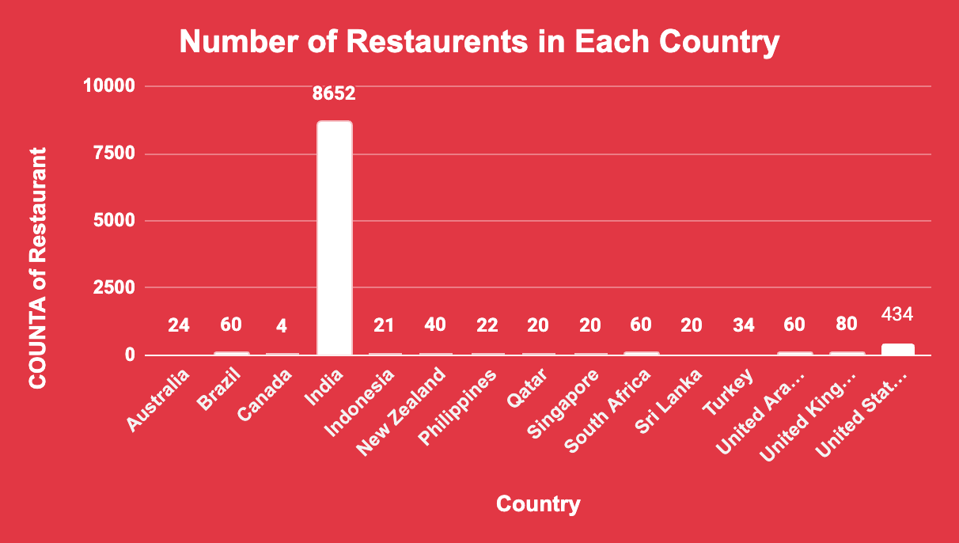

**Q7)Also, the management wants to look at the number of restaurants opened each year, so provide them with something here?**

Ans7)

| *Opening_Year* | COUNT of Restaurant |
| --- | --- |
| 2010 | 1080 |
| 2011 | 1098 |
| 2012 | 1022 |
| 2013 | 1061 |
| 2014 | 1051 |
| 2015 | 1024 |
| 2016 | 1027 |
| 2017 | 1086 |
| 2018 | 1102 |
| **Grand Total** | **9551** |

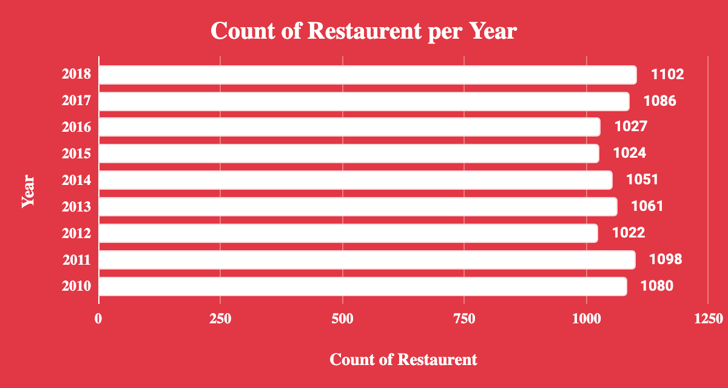

**Q8)What is the total number of restaurants in India in the price range of 4?**

Ans8) the total number of restaurants in india price range of 4 is 388.

**Q9) What is the average number of voters for the restaurants in each country according to the data?**

Ans9)

|  |  |
| --- | --- |
| Average of Votes |  |
| Country | Total |
| Australia | 111.4166667 |
| Brazil | 19.61666667 |
| Canada | 103 |
| India | 137.212552 |
| Indonesia | 772.0952381 |
| New Zealand | 243.025 |
| Philippines | 407.4090909 |
| Qatar | 163.8 |
| Singapore | 31.9 |
| South Africa | 315.1666667 |
| Sri Lanka | 146.45 |
| Turkey | 431.4705882 |
| United Arab Emirates | 493.5166667 |
| United Kingdom | 205.4875 |
| United States of America | 428.2211982 |
| Grand Total | 156.9097477 |

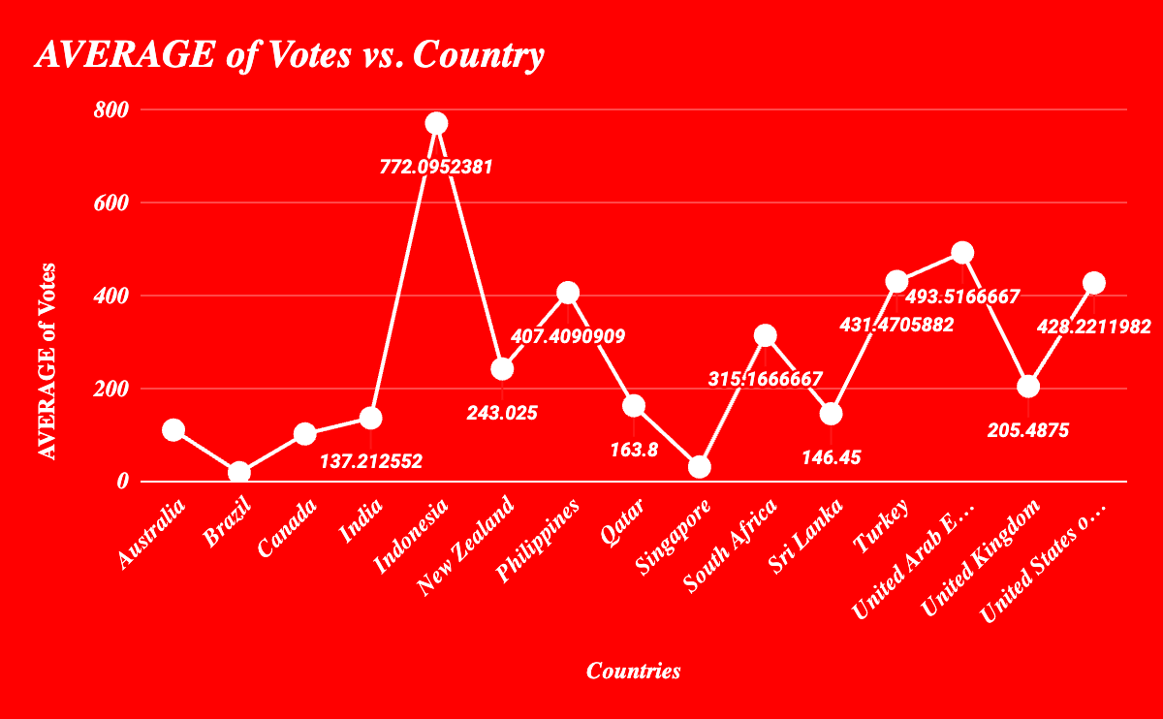

Q10) Calculate the average rating for all the restaurants that have price_range < 4 and provide online delivery. Use only the “IF” function, Logical Operators, and Aggregation functions to solve this problem. [Note: Don’t use Conditional aggregation in this question.]

Ans10)

We will create a Column Average Rating with using this formula =IF(AND(R2<4,O2="Yes"),V2,"") and after that, we will take the average of that column by using =AVERAGE('Raw Data'!W1:W9552)and the average rating was 3.27381151.

Q11) Using Conditional formatting highlights the rows of restaurants that are located in the countries or cities that you’ve suggested to the management for opening new restaurants.

Q12) Create a new customized price column that consists of the abbreviation/symbol of the currency along with the Average_cost_for_two value.[Use string operations to do this task]

Ans12)

First we will make a Symbol column at the right of the Currency column and we will extract symbols by using this formula =REGEXEXTRACT(L3, "\((.*?)\)").

Secondly we will make a Customized Prize column and will fill that column by applying concatenation of Average_cost_for_two column and Symbol column by using this formula =CONCATENATE(M2,T2) .

Q13) How can you create an array formula in Excel or Google Sheets to count the number of restaurants listed that do not offer online delivery, are in the lowest price range, and have an average cost for two people less than or equal to 250 Indian Rupees?

Ans13)

=ArrayFormula(COUNTIFS('Raw Data'!D2:D,"India",'Raw Data'!O2:O,"No",'Raw Data'!R2:R,"1",'Raw Data'!T2:T,"<=250"))

**Subjective Question:**

Q1)Suggest a few countries where the team can open newer restaurants with lesser competition. Which visualization/technique will you use here to justify the suggestions?

Ans 1)

| *Country* | COUNT of Restaurants | AVERAGE of Rating |
| --- | --- | --- |
| Australia | 24 | 3.66 |
| Canada | 4 | 3.575 |
| Indonesia | 21 | 4.30 |
| New Zealand | 40 | 4.2625 |
| Qatar | 20 | 4.06 |
| Singapore | 20 | 3.58 |
| Sri Lanka | 20 | 3.87 |
| Turkey | 34 | 4.30 |
| **Grand Total** | **183** | **4.04** |

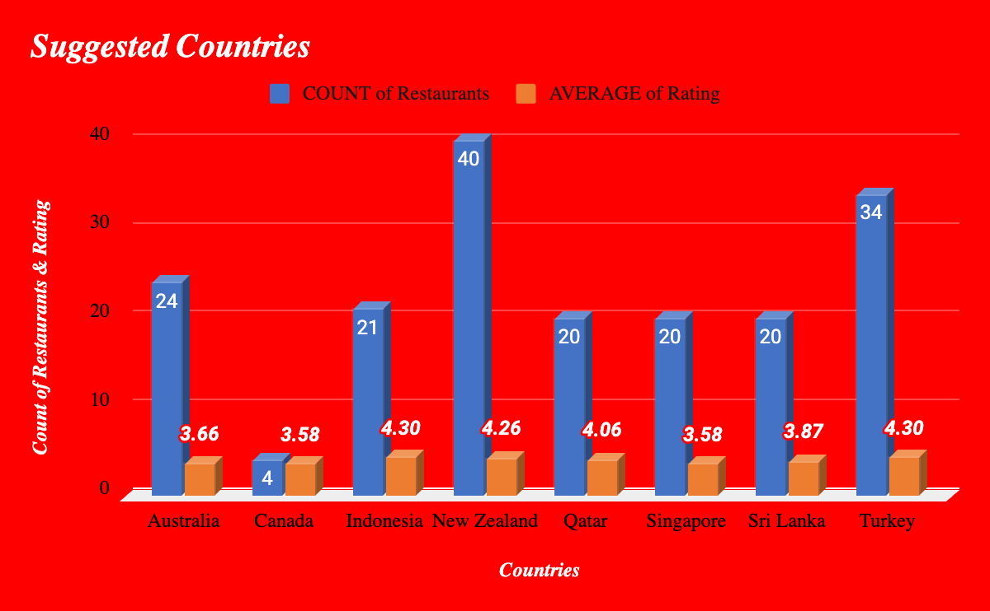

Q2) Come up with the names of States and cities in the suggested countries suitable for opening restaurants ?

Ans2)

| *Country* | *City* | COUNT of RestaurantID | AVERAGE of Rating |
| --- | --- | --- | --- |
| Australia | Armidale | 1 | 3.50 |
|  | Balingup | 1 | 3.20 |
|  | Beechworth | 1 | 4.60 |
|  | Dicky Beach | 1 | 3.60 |
|  | East Ballina | 1 | 4.10 |
|  | Flaxton | 1 | 3.50 |
|  | Forrest | 1 | 3.70 |
|  | Hepburn Springs | 2 | 3.80 |
|  | Huskisson | 1 | 4.10 |
|  | Inverloch | 1 | 3.70 |
|  | Lakes Entrance | 1 | 3.80 |
|  | Lorn | 1 | 3.60 |
|  | Macedon | 1 | 3.50 |
|  | Mayfield | 1 | 2.90 |
|  | Middleton Beach | 1 | 3.80 |
|  | Montville | 1 | 2.40 |
|  | Palm Cove | 1 | 4.40 |
|  | Paynesville | 1 | 2.60 |
|  | Penola | 1 | 3.40 |
|  | Phillip Island | 1 | 3.70 |
|  | Tanunda | 1 | 4.40 |
|  | Trentham East | 1 | 4.10 |
|  | Victor Harbor | 1 | 3.60 |
| Australia Total |  | 24 | 3.66 |
| Canada | Chatham-Kent | 1 | 3.70 |
|  | Consort | 1 | 3.00 |
|  | Vineland Station | 1 | 4.30 |
|  | Yorkton | 1 | 3.30 |
| Canada Total |  | 4 | 3.58 |
| Indonesia | Bandung | 1 | 4.20 |
|  | Bogor | 2 | 3.85 |
|  | Jakarta | 16 | 4.36 |
|  | Tangerang | 2 | 4.30 |
| Indonesia Total |  | 21 | 4.30 |
| New Zealand | Auckland | 20 | 4.28 |
|  | Wellington City | 20 | 4.25 |
| New Zealand Total |  | 40 | 4.26 |
| Qatar | Doha | 20 | 4.06 |
| Qatar Total |  | 20 | 4.06 |
| Singapore | Singapore | 20 | 3.58 |
| Singapore Total |  | 20 | 3.58 |
| Sri Lanka | Colombo | 20 | 3.87 |
| Sri Lanka Total |  | 20 | 3.87 |
| Turkey | Ankara | 20 | 4.31 |
|  | Istanbul | 14 | 4.29 |
| Turkey Total |  | 34 | 4.30 |
| **Grand Total** |  | **183** | **4.04** |

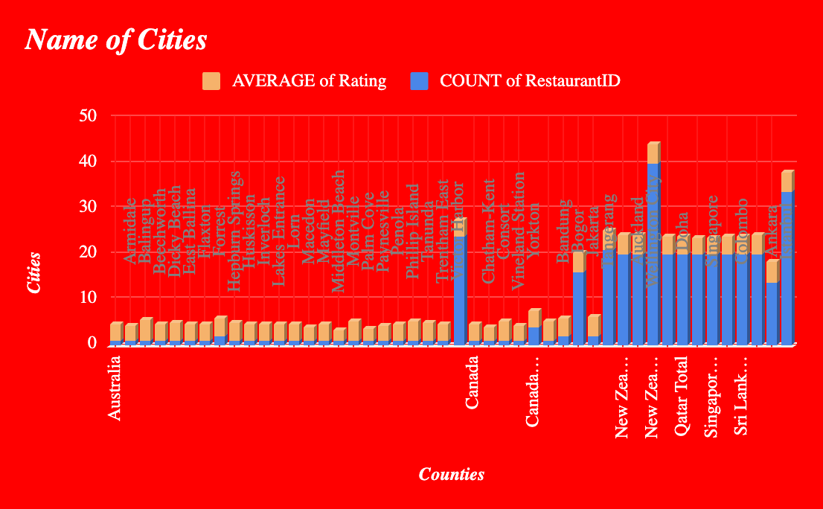

Q3) According to the countries you suggested, what is the current quality regarding ratings for restaurants that are open there?

Ans3)

| *Country* | COUNT of RestaurantID | AVERAGE of Rating |
| --- | --- | --- |
| Australia | 24 | 3.66 |
| Canada | 4 | 3.58 |
| Indonesia | 21 | 4.30 |
| New Zealand | 40 | 4.26 |
| Qatar | 20 | 4.06 |
| Singapore | 20 | 3.58 |
| Sri Lanka | 20 | 3.87 |
| Turkey | 34 | 4.30 |
| **Grand Total** | **183** | **4.04** |

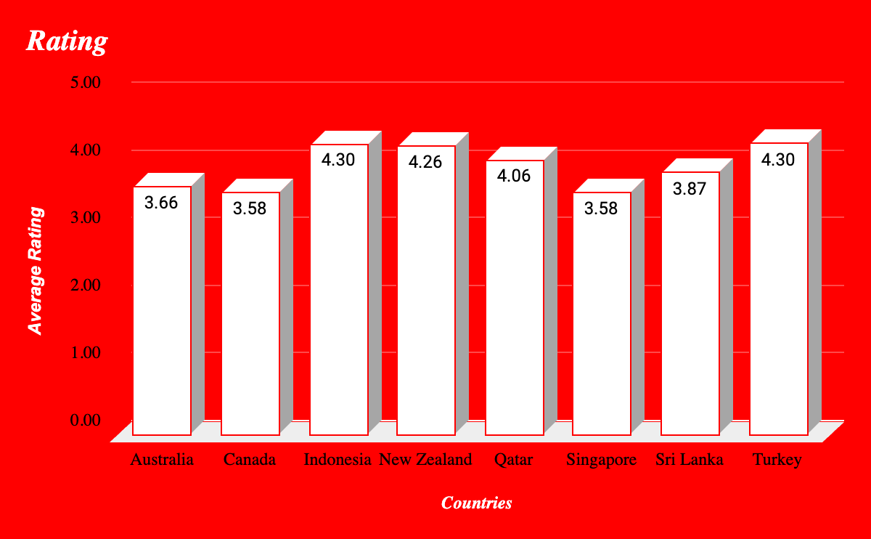

Q4) Also, what is the current expenditure on food in the suggested countries, so we can keep our financial expenditure in control?

Ans 4)

| *Country* | AVERAGE of Average_Cost_for_two | **Coverted in US Dollar ($)** |
| --- | --- | --- |
| Australia | 24.08 | 16.06$ |
| Canada | 36.25 | 26.7$ |
| Indonesia | 281190.48 | 18.26$ |
| New Zealand | 69.75 | 42.88$ |
| Qatar | 223.75 | 61.25$ |
| Singapore | 155.75 | 119.62$ |
| Sri Lanka | 2375.00 | 7.9$ |
| Turkey | 84.85 | 2.49$ |

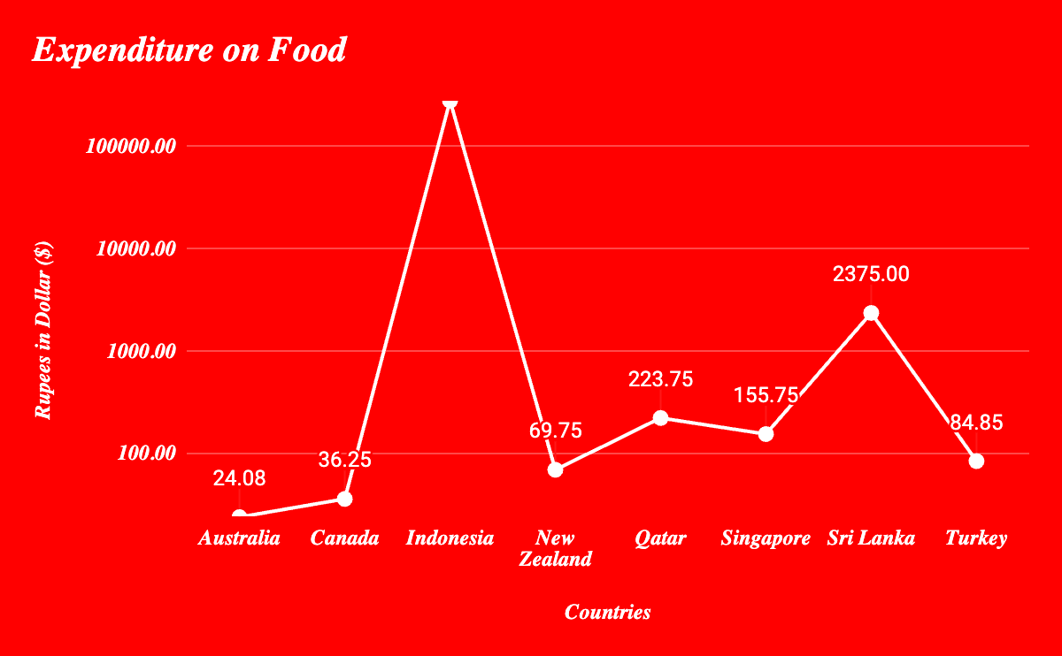

Q7) According to our current data, should we go for online delivery and table booking? Does that affect the customer’s ratings?

Ans7)

Yes we can go for online delivery & table booking because the average rating is higher !

| *Has_Online_delivery* | AVERAGE of Rating |
| --- | --- |
| No | 2.754309859 |
| Yes | 3.288004896 |
| **Grand Total** | **2.89126793** |

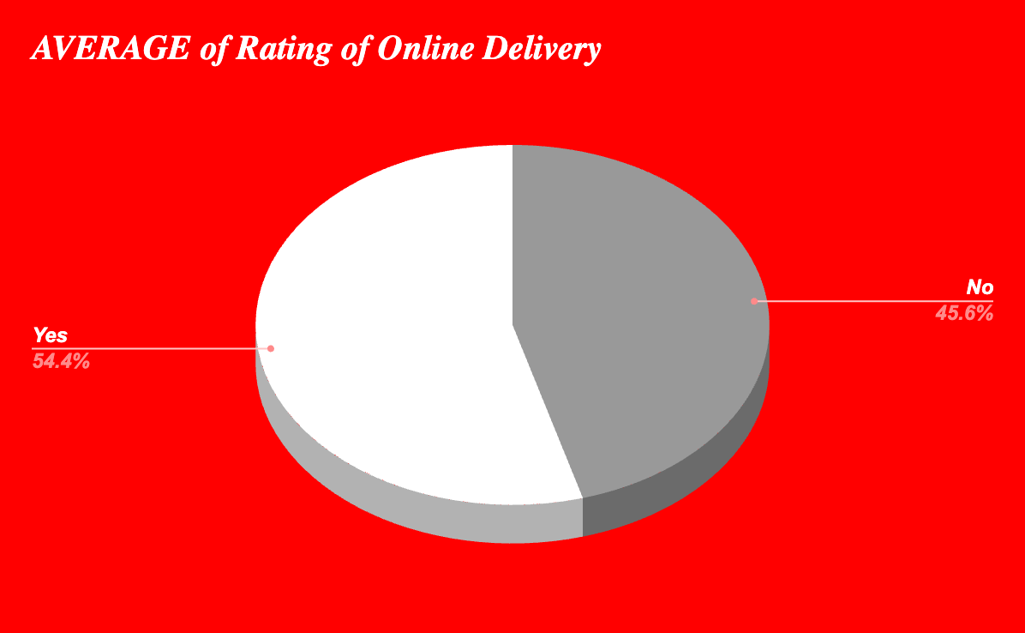

| *Has_Table_booking* | AVERAGE of Rating |
| --- | --- |
| No | 2.809686644 |
| Yes | 3.482556131 |
| **Grand Total** | **2.89126793** |

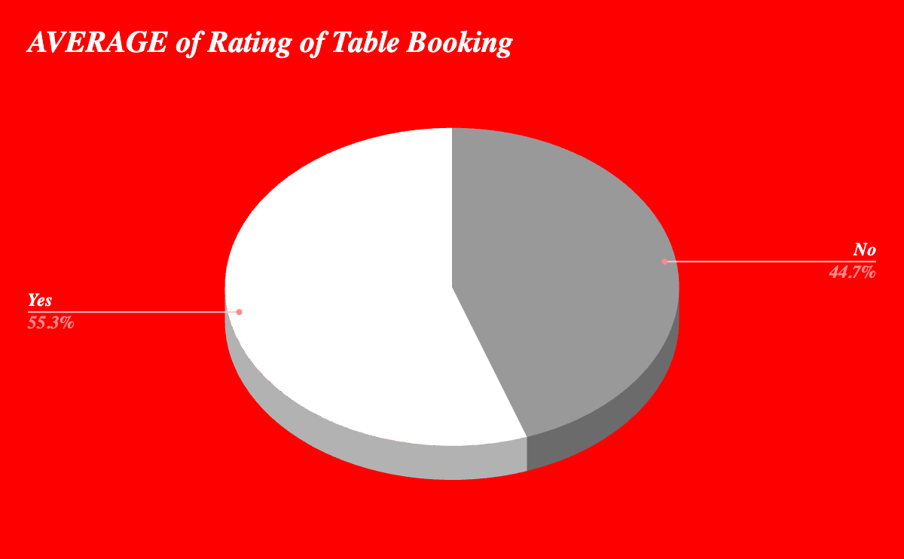

Q9) What is the distribution of the number of restaurants of different price ranges in all the countries?

Ans9)

| *Price_range* | COUNT of RestaurantID |
| --- | --- |
| 1 | 4444 |
| 2 | 3113 |
| 3 | 1408 |
| 4 | 586 |
| **Grand Total** | **9551** |

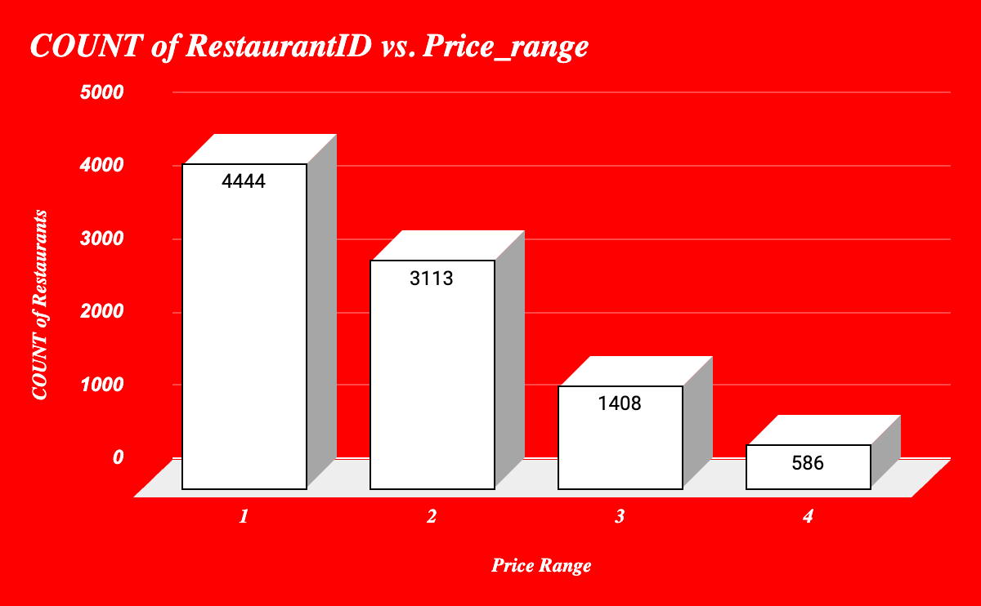

Q10) Explain your approach in brief for suggesting countries/cities in order to open new restaurants, if the objective and subjective questions would have not been given to assist you. **[you have to give bullet pointers in order to answer this question]**

Ans10)

* First i clean the data
* Add column Country and add countries through countries description table
* After i check the number of restaurants in each country
* Then check the where the lesser number of restaurants
* Then check the ratings for those restaurants
* I check where the less restaurants & ratings
* And also check the price range
* Based on that I suggest the countries for new restaurant openings.

# 

# 

# ***DashBoard***

